Template Assessment Summary Report
*This is an example of output the DSAF application can provide for various users. Fisheries and Ecosystem management sectors can use this summary of results to support decision-making and risk-based assessment processes.

**Purely for demonstration purposes, the example chosen here is of a “climate winner”, which is a hypothetical species anticipated to benefit from climate change in the user-selected management area.

For Species X in selected management Region 1

Overall Climate Risk (Triaging Step)
Species X overall has a Negligible Risk of negative climate change impacts in the user-selected Region1 according to results of the Climate Risk Index for Biodiversity assessment (Boyce et al. 2022; illustrated below). In the following sections, indicators of current and potential future distribution shift of this species in Region1 and surrounding areas will be summarized to provide further details of relevance to fisheries management.

<< This image is a placeholder for a map of Species X overall climate risk, as assessed using the CRIB approach, in Region1 >>
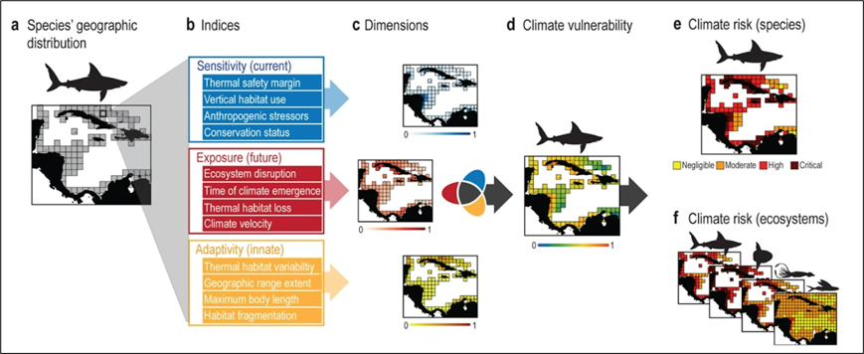
Figure 1. Climate Risk Index for Biodiversity (CRIB) methodology (Boyce et al. 2022)​

Current trends in Abundance and Distribution:​
Overall, species X is expanding northward into the selected Region1. This is exemplified by the northerly shift in the leading range edge of its distribution, which falls within selected Region1 (shown in green in plots below), relative to a lack of significant movement of its trailing edge in the reference Region2 (shown in blue in plots below). In the selected management Region1, this species is increasing slightly in abundance and area occupied, while not shifting in depth spatial distribution. The species is also increasing in abundance and area occupied in the reference Region2.
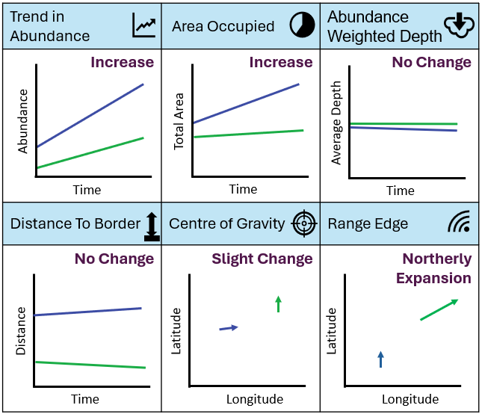

Future expected conditions:
This location is projected to become more suitable to species X over time. This is exemplified by overall Negligible climate change risk for the species in the selected management area, and the prediction that the area will not become intolerably warm for the species in the next 80 years (time of emergence > 2100), even under a future climate scenario driven by continued increases in global greenhouse gas emissions.
*In future, this section can also contain results from SDM projections, predicting future distribution of the species relative to the selected management area under multiple future climate change scenarios.

<< PLACEHOLDER FOR CRIB TIME OF EMERGENCE INDEX RESULTS >>

Potential Impacts on Fishery Objective:
*Note that this section will change following consultation with fisheries management end users

Example Summary:
These results indicate Negligible Risk of negative climate impact on SSB​ for this species in the selected management area in the next 5-10 years (probability = X% and X% under high and low future emissions scenarios, respectively), particularly given general overall expansion of the species in Canadian waters (Region1 and reference Region2). Lack of shift in depth distribution indicates no changes to existing fishing strategies are needed. If no existing fishery exists for Species X in Region1, then the policy for new and emerging fisheries may be consulted for consideration.

This section will provide a summary of DSAF assessment results to support fisheries managers in answering critical questions, which may include the following:
- Is the species shifting relative to selected fisheries management area(s)? If so, which areas and how (moving into or out of the area)?
  - Is stock likely to persist or disappear from area?
- If not currently shifting relative to the selected area, what is the expectation of when the species will shift in or out?
  - When will area become too warm or just right for the stock?
- What is the uncertainty associated with modelled current and future trends?
- What is level of risk we are willing to accept before modifying recommendations for the management of Species X in Region1?

